Sacrament of Penance/Reconciliation - A sacrament of healing

Opening Prayer
I confess to almighty God and to you, my brothers and sisters, that I have greatly sinned, in my thoughts and in my words, in what I have done and what I have failed to do, through my fault, through my fault, through my most grievous fault; therefore, I ask blessed Mary Ever-Virgin, all the Angels and Saints, and you my brothers and sisters, to pray for me to the Lord our God. Amen

The sacraments are efficacious signs of grace, instituted by Christ and entrusted to the Church, by which divine life is dispensed to us. CCC1131

Matter: Confession Form: The priest’s words of absolution Who: Bishop or Priest as ordinary minister.

The Sacrament of Reconciliation heals and purifies us and reconciles us with God and the Church.
"Therefore, confess your sins to each other and pray for each other so that you may be healed. The prayer of a righteous person is powerful and effective" James 5:16
"If we confess our sins, he is faithful and just and will forgive us our sins and purify us from all unrighteousness."1 John 1:9
What is sin? - Turning away from God, disobeying God's commandments, an offense against God, a rupture of communion with him and the church.

Satan has two main tools to use against us - Sin and Death. The worst kind of death is not the body, but the soul.

If baptism forgives all sins and brings new life in Christ, why must we confess our sins after baptism? - The new creation received in Baptism does not take away the weakness of our human nature nor the inclination to sin called concupiscence. Baptism wipes out original sin, but all mortal sins committed after our Baptism must be cleansed in the confessional, which through God’s grace transforms us of from being out of a state of grace to being back in the state of grace and saves our soul. Every confession is a major spiritual resurrection, because God and his divine life is able to come back into our soul. Venial sins are cleansed during the penitential rite at mass, along with when we receive Holy Communion. So, If you have gone to confession for all your mortal sins and then you go to mass, your venial sins are forgiven during the penitential rite, if you don’t sin in mass from the penitential rite until you receive communion you are completely spotless.

What is Mortal (Grave) Sin - Any sin whose matter is grave and which has been committed willfully and with knowledge of its seriousness. Grave matter includes, but is not limited to, murder, receiving or participating in an abortion, homosexual acts, having sexual intercourse outside of marriage or in an invalid marriage, and deliberately engaging in impure thoughts (Matt. 5:28–29). Scripture contains lists of mortal sins (for example, 1 Cor. 6:9–10 and Gal. 5:19–21). For further information on what constitutes a mortal sin, see the Catechism of the Catholic Church. Mortal sin, also known as grave or deadly since, destroys the life of the grace in your soul. It would like kicking God out of your heart. See further details in CCC1858.

What is Venial sin? - Violations of God's law that do not sever the relationship with him or destroy life of grace in the soul.

Biblical evidence that not all sins equal
1 John 5:13-21 - "If anyone see his brother sinning, if the sin is not deadly, he should pray to God and he will give him life. This is only for those whose sin is not deadly. There is such a thing as deadly sin, about which I do not say that you should pray. All wrongdoing is sin, but there is sin that is not deadly."

James 1:14 -15 "Rather, each person is tempted when he is lured and enticed by his own desire. Then desire conceives and brings forth sin, and when sin reaches maturity, it gives birth to death."

The priest forgives our sins with the authority that was given to them by Jesus to exercise in his name. Jesus delegated the ministry of confession and the authority to forgive sins to his apostles and this is a living office that is passed on through the laying on of hands.

We take our body ailments to a medical doctor, so why would we not take our ailing Spirit to the doctor of the soul (A priest).

The church precept is to participate in the sacrament of confession at least once a year. The ideal seasons are Advent and Lent. However, it is recommended to confess more often such as quarterly or monthly. We cannot receive the Holy Sacrament of the Eucharist if we are in mortal sin.

“Whoever, therefore, eats the bread or drinks the cup of the Lord in an unworthy manner will be guilty of profaning the body and blood of the Lord. Let a man examine himself, and so eat of the bread and drink of the cup. For anyone who eats and drinks without discerning the body eats and drinks judgement upon himself.” 1 Cor. 11:27–28

The Didache an early Christian document written around A.D. 70 witnesses to this practice of the early Church. “Whosoever is holy [i.e., in a state of sanctifying grace], let him approach. Whosoever is not, let him repent” (Didache 10). “But first make confession of your faults, so that your sacrifice may be a pure one” (Didache 14).
Biblical evidence that God gave the Apostles and their successors the authority to forgive sins
Matthew 9:5-8
"Which is easier to say, "Your sins are forgiven, or to say, "Rise and walk?" But that you may know that the Son of Man has authority on earth to forgive sins" he then said to the paralytic, "Rise, pick up your stretcher, and go home." He rose and went home. When the crowds saw this, they were struck with awe and glorified God who had given such authority to human beings.

John 20:23
"As the Father has sent me, so I send you (speaking to the 12 apostles). And when he has said this, he breathed (Life giving power from God) on them and said to them, "Receive the Holy Spirit. Whose sins you forgive are forgiven them, and who sins you retain are retained."

If Priests can baptize people which wipes away sin, why can't they perform Reconciliation which absolves people of sin?

"Amen, I say to you, whatever you bind on earth shall be bound in heaven, and whatever you loose on earth shall me loosed in heaven." This verse shows that this pertains to repented or un-repented sin. Matthew 18:6-20

Confession is the pathway for physical and spiritual healing.
"Is anyone among you sick? He should summon the presbyters (priests) of the church, and they should pray over him and anoint him with oil in the name of the Lord, and the prayer of faith will save the sick person, and the Lord will raise him up. If he has committed any sins, he will be forgiven. Therefore, confess your sins to one another and pray for one another, that you may be healed. The fervent prayer of a righteous person is very powerful." James 5:13-17

Does the Lord forgive us completely when we ask for his mercy? Yes!
"For as the heavens tower over the earth, so his mercy towers over those who fear him. As far as the east is from the west, so far, he removed our sins from us. As a father has compassion on his children, so the Lord has compassion on those who fear him." Psalm 103:11-13

"Repent, then, and turn to God, so that your sins may be wiped away." Acts 3:19

“I am He who blots out your transgressions for my own sake, and I will not remember your sins.” Isaiah 43:25

The greater the sinner the greater the right they have to God's mercy. Our sinfulness cannot keep us from receiving God's mercy.
"Where sin increased, grace abounded all the more" Romans 5:20

Once our sins are forgiven, they no longer exist to not only God, but to the demons as well. They can't accuse of sins we have confessed. Satan desperately does not want us to go to confession and for that matter to eat of the Body and Blood of Christ

What do unconfessed sins do to us? We slowly become a slave to Satan, because he knows our unconfessed sins and he then uses them to accuse us, put us down, make us feel unworthy of God's love, that we are so bad God will never forgive us.

"But your iniquities have made a separation between you and your God, and your sins have hidden his face from you so that he does not hear". Isaiah 59:2
"For you are not a God who delights in wickedness; evil may not dwell with you." Psalm 5:4
"Repent therefore, and turn back, that your sins may be blotted out, that times of refreshing may come from the presence of the Lord". Act 3:19-20
"Cast me not away from your presence, and take not your Holy Spirit from me". Psalm 51:11
Unrepented sins are like portals that allow Satan/death to enter our body and soul to destroy us. The longer we go without confession our sins the larger the holes and entrances become for him to enter us. DO NOT listen to the voice that says, "You don't need to confess your sins to a priest." This is a lie and all lies come from the author of lies (Satan).

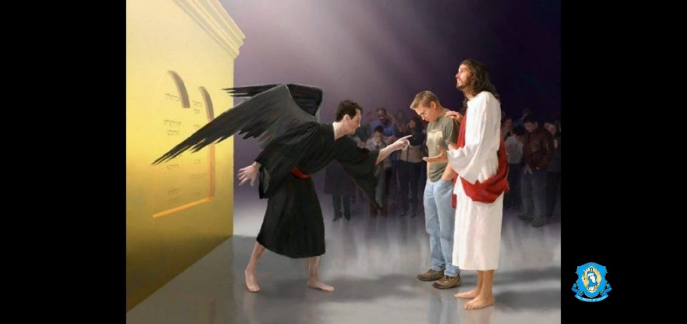

Is there Sin that is not forgiven?
"Therefore, I say to you, every sin and blasphemy will be forgiven people, but blasphemy against the Spirit will not be forgiven. And whoever speaks a word against the Son of Man will be forgiven; but whoever speaks against the holy Spirit will not be forgiven, either in this age or in the age to come." Matthew 12:31
What is Blasphemy against the Spirit? - Not asking for God's Mercy. The sin of attributing to Satan (Matthew 12:24) what is the work of the Spirit of God. (Matthew 12:28)

Steps Prior to the Sacrament of Reconciliation

- Prayer first prior to examination of conscience
"Come, Holy Spirit, enlighten my mind that I may clearly know my sins. Move my heart that I may be sincerely sorry for them, honestly confess them and firmly resolve to amend my life. Spirit of Wisdom, grant me to see the malice of my sin and my ingratitude toward You, the all-loving God. Spirit of Fortitude, help me to make whatever sacrifice is needed to avoid sin in the future. Amen.

- Do an Examination of Conscience - becoming aware of your sins
- Examination of Conscience for Adults and Teen "Fathers of Mercy" pamphlet (Use 10 commandments and the 7 deadly sins)
- There is an examination of conscience activity on the Amen app
- It’s a good practice to do a daily examination at the end of the day as part of your prayer life

Note: Try to remember your sins in number and kind. You don't always need tell all the details and you must not be overly vague.
Ex. for a sexual sin, the priest may want to know if you were impure with yourself or another person and if was an act or a thought. This helps the priest understand the sin committed.

10 Commandments - Catholics take them from Deuteronomy

- I am the Lord your God. You shall not have strange gods before me.
  - Do I see to love God with my whole heart and soul?
  - Does He truly hold the first place in my life?
  - Do I give God time every day in prayer?
  - Are there things more important in my life than God?
  - Have I been involved with superstitious practices or the occult?
  - Do I seek to do God's will or my will in my life?
  - Have I ever received Holy Communion in the state of mortal sin?
  - Have I told a lie in confession or deliberately withheld confessing a mortal sin?
  - Have I denied a truth of the Catholic Faith out of embarrassment?
  - Have I presumed that God would forgive me?

- You shall not take the name of the Lord your God in vain.
  - Have I condemned someone in God's name? - misuse of God's name and power GD.
  - Do I say His name when I am angry
  - Have I used God's name lightly or carelessly? OMG!
  - Have I insulted a sacred person (priest) or abused a sacred object? (Eucharist)
  - Have I broken a vow made in God's name?

- Remember to keep holy the Lord's Day.
  - Do I reflect on the meaning of the resurrection every Sunday?
  - Have I deliberately missed Mass on Sundays or Holy Days of Obligation?
  - Do I take the mass seriously. Do I arrive late or leave early without a good reason?
  - Have I tried to observe Sunday as a family day and a day of rest, which includes prayer?
  - Do I needless work or activities on Sunday, like shopping, that forces others to work?

- Honor your father and your mother.
  - Do I honor and obey my parents?
  - Do I try to bring peace into my home life?
  - Have I neglected my family responsibilities to spouse and children?
  - Have I provided adequate care for my parents?
  - Have I instilled faith & discipline in my kids?
  - Have I been disrespectful to my superiors?
  - Have I criticized politicians without praying for them first?
  - Have I broken the law thinking it is no "big deal" like the speed limit?
  - Have I cheated on my taxes?

- You shall not kill.
  - Have I murdered or physically harmed anyone?
  - Have I had an abortion or encouraged anyone to have an abortion?
  - Have I abused alcohol or drugs, which can indirectly lead to destruction of the body/life?
  - Did I give scandal to anyone, leading him or her into sin? (killing their soul)
  - Have I harbored hatred in my heart, wishing them death or worse, to go to hell?
  - Have I condoned sterilization or other forms of birth control?
  - Have I engaged in sins against human life such as artificial insemination or in vitro fertilization?
  - Have I approved euthanasia?
  - Have I actually taken someone's life either directly or indirectly?
  - Have I harbored hatred, anger, or resentment in my heart towards anyone?

- You shall not commit adultery.
  - Have I been unfaithful to my marriage vows in action or thought?
  - Was I married outside the Church without permission of the Church?
  - Have I engaged in any sexual activity with another person outside of marriage?
  - Have I engaged in impure acts by myself?
  - Has each sexual act in my marriage been open to new life?
  - Do I seek to be chaste/pure in my thoughts, words, actions?
  - Am I careful to dress modestly? (Men and Women)
  - Have I indulged in pornographic material?
  - Am I engaged in any inappropriate relationships?

- You shall not steal.
  - Have I returned or made restitution for what I have stolen?
  - Do I waste time at work, school, home?
  - Have I lied about my hours at work or claimed someone else's ideas as my own?
  - Do I gamble excessively, thereby denying my family of their needs?
  - Do I pay my debts promptly?
  - Do I seek to share what I have with the poor and needy?
  - Have I cheated anyone out of what is justly theirs: creditors, insurance company, even IRS?

- You shall not bear false witness against your neighbor.
  - Have I lied, even "white lies?"
  - Do I speak badly of others behind their back?
  - Do I gossip or participate in gossip?
  - Am I critical, negative or uncharitable in my thoughts of others?
  - Do I keep secret what should be kept confidential?
  - Bragging (false of oneself) and exaggerated flattery (false things of another) are a sin
  - Am I sincere in my dealings with others or am I "two-faced?"

- You shall not covet your neighbor's wife.
  - Am I envious of another's spouse or family?
  - Have I caused impure thoughts by reading, movies, TV, conversation or curiosity?
  - If I know a movie has sexual content, do I watch it anyway?
  - Do I pray at once to banish impure thoughts and temptations?
  - Have I flirted with someone not my spouse?

- You shall not covet your neighbor's goods.
  - Am I jealous of what other people have?
  - Are material possessions the purpose of my life?
  - Do I have attachments to things? (cell phones, laptops, car, house, TV, fish rods, boats, ATVs, shoes, clothes, purses, jewelry)
  - Am I upset when I see the success of someone else?
  - Am I resentful and bitter over my position in life?

7 Deadly Sins (Vices) with corresponding Virtues – We all usually have 2 Vices that are harder for us to overcome that stick out in our lives.

Vices (The Root of Sin) | Virtue (The Cure)
Pride/Vanity – Care too much about what others think, especially those that are not close to us. We should not seek to be praised, but see to be praiseworthy. Don’t worry about being honored, but what is honorable  “There is not one soul in heaven with the sin of Pride.” C.S. Lewis | Humility - Confession teaches humility. Awareness that all of our gifts come from God. “There is not one soul in hell with the virtue of humility”- St. Augustine
Envy – sadness at the site of another’s gifts/goods and a desire to acquire them. Pleasure from another’s downfall. Ex. Gossip | Charity towards neighbor
Gluttony – When we are extremely picky, uncharitable, grumpy about what we eat. Use food, drugs, alcohol to manage our emotions. | Temperance (Self-Control)
Lust – desire to use another person sexually to get what we want. Ex. Pornography | Chastity – self -mastery, purity of mind and heart. When we put on Christ and make ourselves an offering to others.
Anger – Sinful when used to get our way, too intense, lasts too long, inappropriate. | Meekness – serenity of spirit while focusing on the needs of others.
Avarice/Greed – disordered love of money, used to measure success. | Generosity – giving of one’s self in cheerful manner for the good of another.
Sloth – A boredom, a sadness, a hatred for spiritual things. Lacks courage to the call of greatness. An aversion to prayer, the mass, the Eucharist. Escapes the invitation to holiness. Symptoms – Busy, distracted, restlessness | Diligence – fortitude, decisive work ethic, steadfastness in belief.

“Pray that your confessor understands you and God gives him the grace and wisdom to guide us. St. Faustina Diary 647

"Let the sinner not be afraid to approach Me. The flames of mercy are burning Me - clamoring to be spent; I want to pour them out upon these souls. – St. Faustina Diary, 50)

"The Lord has been teaching me, once again, how I am to approach the Sacrament of Penance: My daughter, just as you prepare in My presence, so also you make your confession before Me. The person of the priest is, for Me, only a screen. Never analyze what sort of a priest it is that I am making use of; open your soul in confession as you would to Me, and I will fill it with My light" (St. Faustina Diary, 1725).

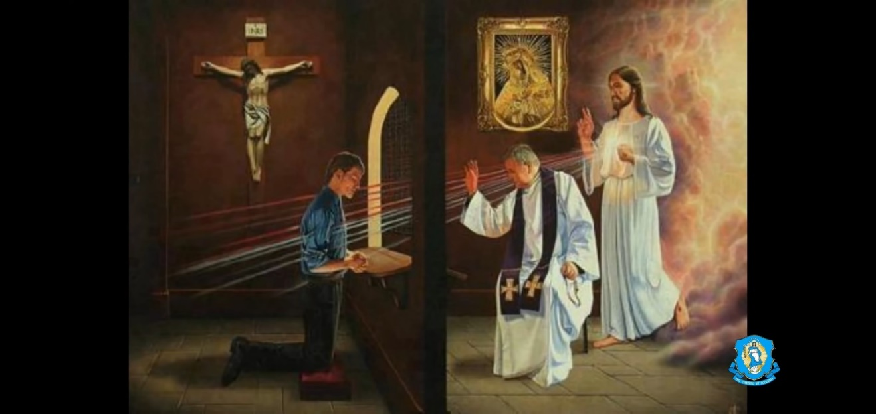

Steps for the Sacrament of Reconciliation

- Greet priest, make sign of cross
- Say…”Bless me Father for I have sinned” it has been xxxx since my last confession.
- List all your grave sins and any others that are on your heart.
- Listen to advice, answer any questions
- Accept Penance
- Pray the Act of Contrition
My God, I am sorry for my sins with all my heart. In choosing to do wrong and failing to do good, I have sinned against you whom I should love above all things. I firmly intent, with your help, to do penance, to sin no more, and to avoid whatever leads me to sin. Our Savior Jesus Christ suffered and died for us. In his name, my God, have mercy. Amen.

- Receive Absolution - The priest forgives our sins by the grace of God. They are in the person of Christ and there is guaranteed of forgiveness.

Priests Words of Absolution
God, the Father of mercies, (2Cor1:3)
through the death and resurrection of His Son
(2 Cor. 5:19; cf. Rom. 11:15; Col.1:20) has reconciled the world to Himself
(John 20:21-23) and sent the Holy Spirit among us for the forgiveness of sins;
(2 Cor. 5:18-20) through the ministry of the Church
(Luke 7:50; Col. 1:14) may God give you pardon and peace,
and I absolve you from your sins
in the name of the Father, and of the Son,
and of the Holy Spirit.

Do your Penance right after you leave the confessional - If you forget and fail to complete your penance your confession becomes invalid.
Notes:
  - You can go beyond your penance on your own to complete satisfaction if you feel like your sins are more serious than saying just a Hail Mary. Confession heals the wound, because our sin is forgiven. However, a scar still exists on the Body of Christ and our penance/satisfaction can repair this.
  - If you aren't comfortable with the penance, you can ask the priest to assign you another penance and you need to be able to fulfill it.



Optional Prayer after Confession

Almighty and Merciful God, whose mercy is boundless and everlasting and of Whose goodness the riches are infinite, I thank You because You have so graciously pardoned all of my sins and restored Your Heavenly favor. I am awed by your divine compassion and the incomprehensible love of Your Son, which has led him to institute so gentle and powerful a remedy for sins. In union with all the gratitude that has ever ascended to You from truly penitent hearts, I proclaim Your merciful praises on behalf of all in Heavan, on earth and in purgatory, for ever and ever. Amen.

Notes:
- If you purposely withhold from confessing a grave sin, the confession becomes invalid.
- You must have contrition (Sorrow and hatred for sin)
- No matter how broken the priest is he can help us in the confessional, because he was given that power of the priesthood.
- The priest cannot break the seal of confession
- We are not allowed to hear another person’s confession.
- You don't need to confess in front of the priest you can be behind the screen, which is more the traditional way.
- Confession is not the appropriate time for spiritual direction, especially if there is a line for the confession.

The Spiritual Effects of Confession
- Reconciliation with God and the Church – God forgets our sin and Satan can’t be aware of it either, because it’s gone. The sin doesn’t become public to everyone soul at our 2nd judgment.
- Forgiveness of the eternal punishment of mortal sin
- Decrease time in Purgatory with penance and satisfaction
- Tranquility of our conscience and spiritual consolation
- Increase spiritual strength for Christan Combat through graces given to us to overcome the sins we confessed

"I think the main reason we keep returning [to Confession] with the same list [of sins] is that we don't understand what Christ wants to do in the confessional. We go simply wanting our sins forgiven, not realizing that He wants to do much more. He wants to heal us of the attitudes, disordered desires, problems, and wounds that are causing us to keep committing those sins...Since the purpose of every sacrament is to give grace, and the purpose of grace is to heal and sanctify, then the ultimate goal of each sacrament is to heal us and make us holy so that we can become like God." – Vinny Flynn p.26-27 – Seven Secrets of Confession Book

Closing prayer – Psalm 51

Other References

Bible Verses for reflection
- Matthew 18:21-35 - Parable of the Unforgiving Servant
- Luke 15 - Parable of the Lost Sheep, Parable of the Lost Coin, Parable of the Lost Son
- Luke 17: 1-4 - Temptation to Sin
- 2 Corinthians 5:17-21 - Ministry of Reconciliation
- 1 John 2 & 3

Catechism on the Sacrament of Reconciliation – Starts on CC1422

Daily Examination

Examination of Conscience
The daily examination of conscience is an ancient Catholic practice. It's very simple, and it's designed to help us identify our sins and weaknesses so that we can improve and grow stronger in the spiritual life. Basically, it consists in taking a few minutes at the end of the day to prayerfully review our actions in the light of God's commandments. The Act of Contrition is often said afterwards. The daily examination also serves as an excellent ongoing preparation for regular Confession.

Reflect on the victories and losses
Actively reflecting on the high and low points of the day can help you live more intentionally and bring a renewed sense of resolve into the following day.
- Review your actions, words, and thoughts today. Did you actively guard yourself against temptation? Where did sin creep in?
- In what moments did you practice virtue and moral courage?
- Were you attuned to the Holy Spirit's promptings today? Where did you feel His inspiration?
- Ask Him for the graces necessary to follow His Will more purposefully tomorrow.

Act of Contrition
O my God, I am heartily sorry for having offended Thee, and I detest all my sins because of Thy just punishments, but most of all because they offend Thee, my God, Who art all good and deserving of all my love. I firmly resolve with the help of Thy grace to sin no more and to avoid the near occasions of sin. Amen.

Practice gratitude
It is God's love that has brought you into existence and to this exact moment. Practice looking for His hand in your day.
- Where did you feel His loving gaze upon you today?
- What people or moments helped you see God in your life?
- Thank God for all these moments!
- Ask Him to help you recognize His blessings and providence tomorrow.

Renew your commitment to Christ
Remember our Faith is founded upon a Person—Christ! Renew your personal love and devotion to Him.
- Thank God for the gift of His Son Jesus and our call to be His disciples.
- Tell the Lord of your desire to know Christ more personally.
- If possible, set an intention for your day tomorrow. Ask Our Lord to guide you in this act.
- Pray a Hail Mary, Our Father, or another beloved prayer.

