The Scapular – A Religious “Habit”
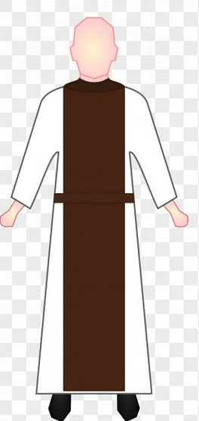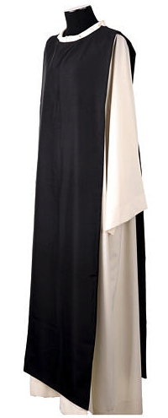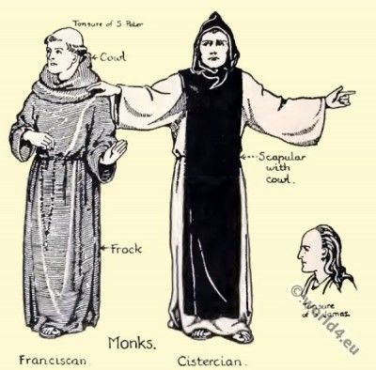
Matthew 11:28-30
²⁸ Come to me, all who labor and are heavy laden, and I will give you rest. ²⁹ Take my yoke upon you, and learn from me; for I am gentle and lowly in heart, and you will find rest for your souls. ³⁰ For my yoke is easy, and my burden is light.”
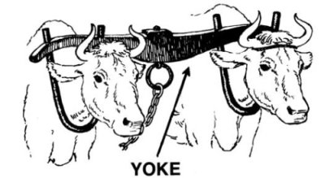
Jesus says, “Take my yoke upon you …”, not the yoke of Torah.
Deacon Henry’s “Scapular of the Heart”:
All for You, most Sacred Heart of Jesus,
Sacred Heart of Jesus, I place my trust in You.
Sacred Heart of Jesus, Your kingdom come.
Jesus, meek and humble of Heart, make my heart like unto Thine.
Jesus, have mercy on me, a sinner!

